CREATEADATABASEINCLOUDANTDB

DATE 24-Nov-2022

TEAMID PNT2022TMID46309

PROJECTNAME IOT Based Smart Crop Protection System for Agriculture

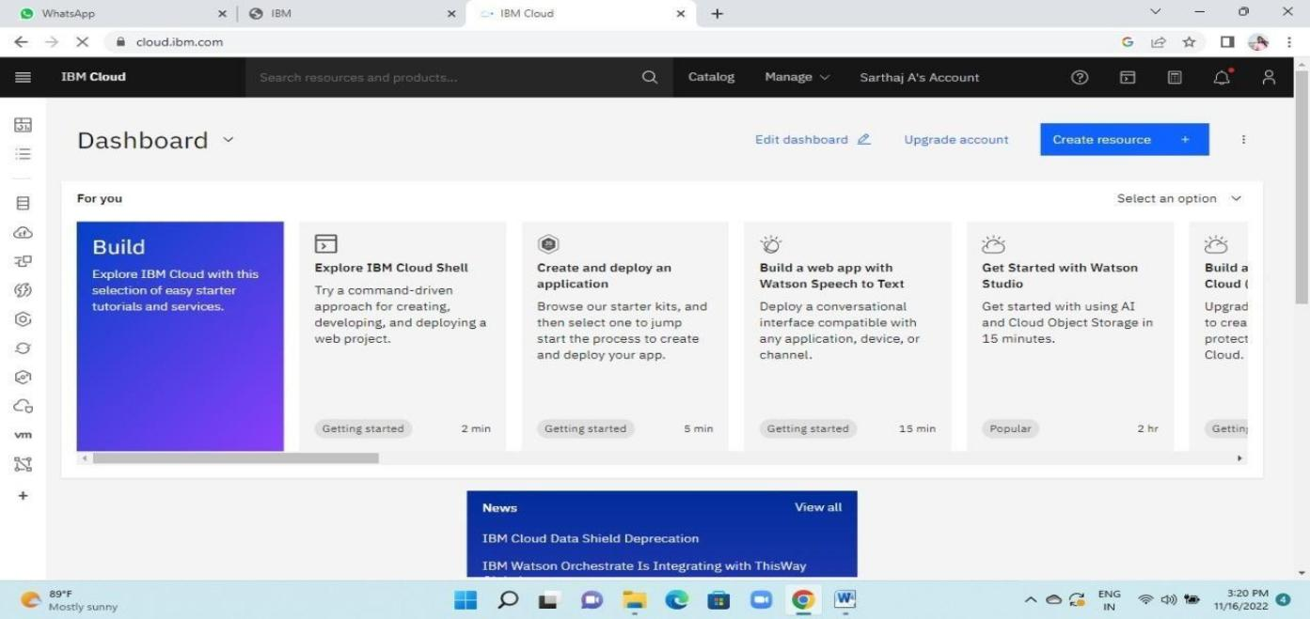**Step1:**UtilizeyouraccountinformationtologintoIBMCloud**.Step2:**accesstheresourcelist

**Step3:**Selectthedatabasefromtheresourcelist where youcanexamine the cloudant service's active status by clicking on thatcloudant.

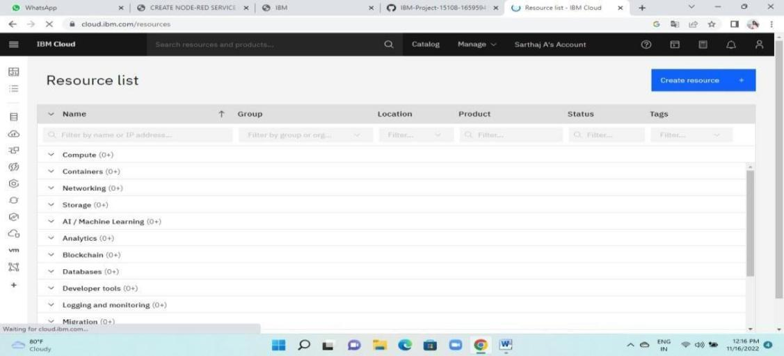

**Step4:**Followingthat,you maysee"LaunchDashboard"inablueboxatthetopandclickonit.

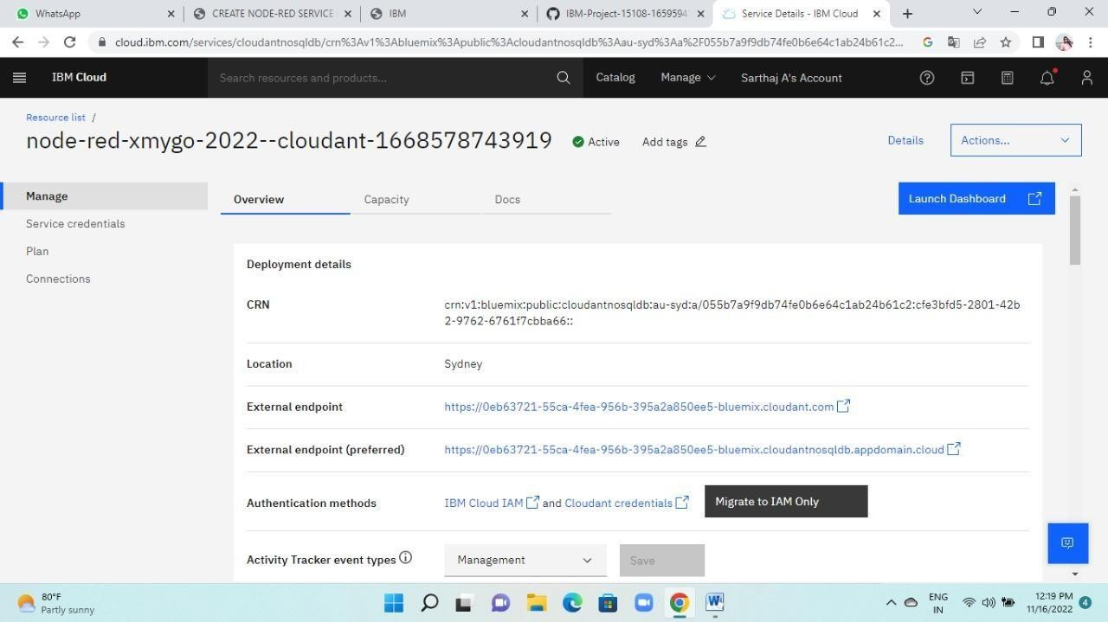

**Step5 :**Afterthat,it willopenasshown below,andyou can createadatabasebyclickingthecreatedatabasebuttonasshown.thenentertheinformationandselect"create"

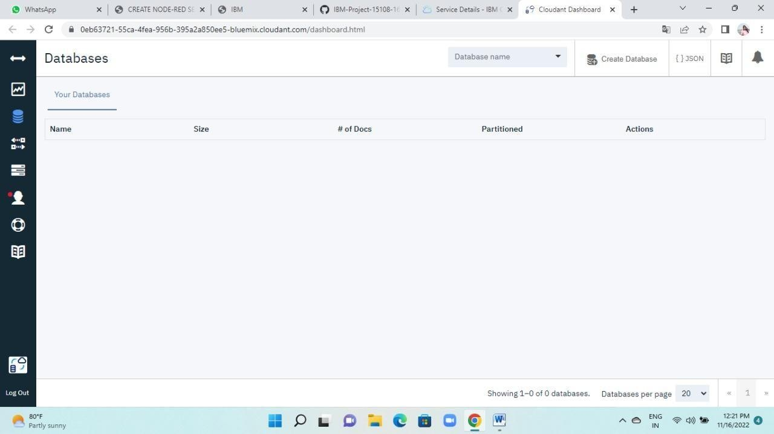

**Step6:**Inorderforthedatabasetobesuccessfullycreated

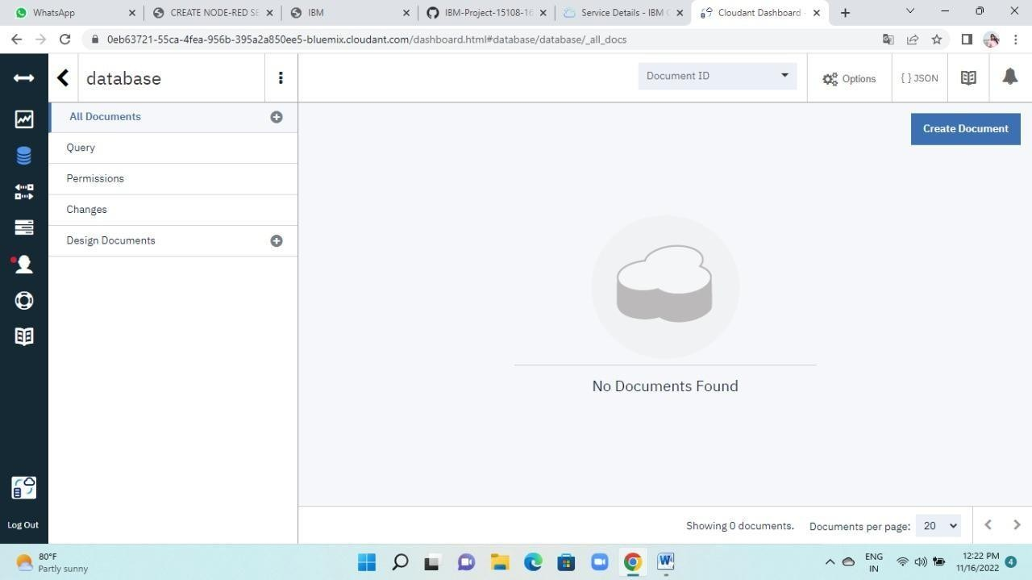

**Step 7 :** Now select Create Document from this database's menu tobeginproducingadocumentthatwillbeusedtocreateadatabaseandstoreanimageURL.

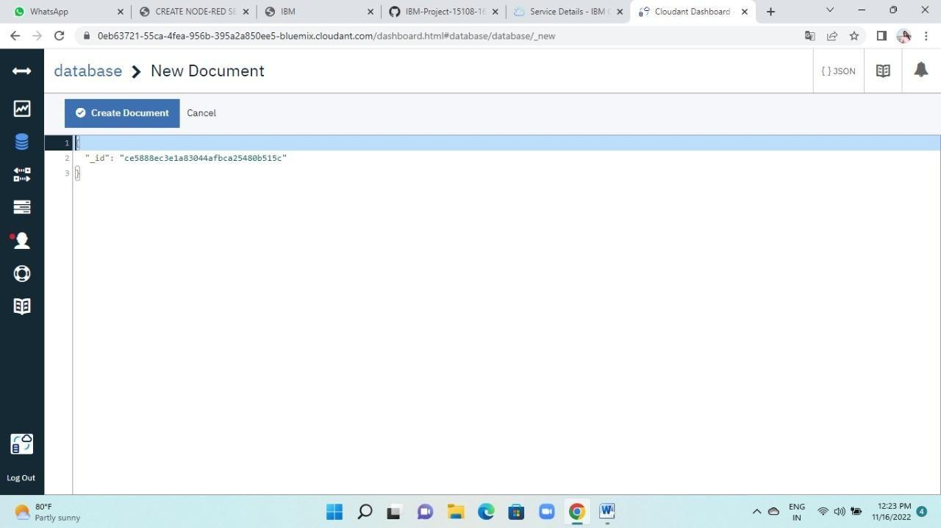

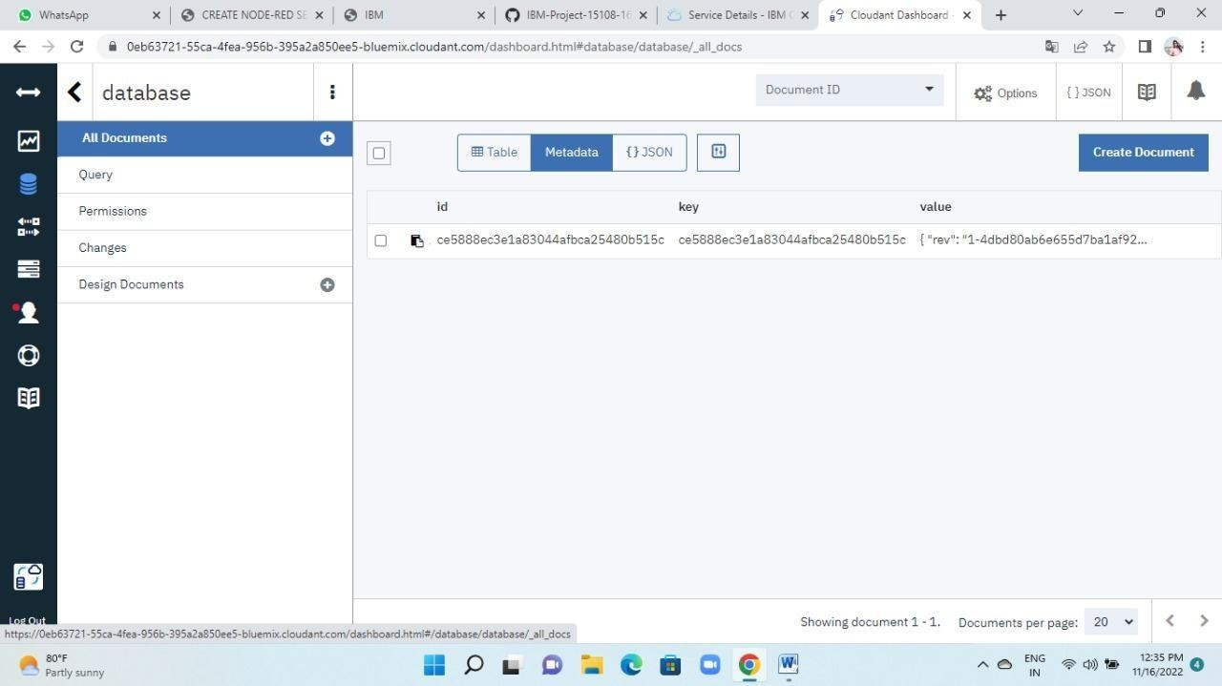

**Step8 :**Consequently,adocumentisproduced

